Name | Sanchay Ambokar
Roll no | 24204B0046
Batch | 03
Subject name | Python Programming & Data Structure
Teacher Name | Ms. Rasika Patil

Experiments | 15
Title | *Develop python program to implement operations (Create, Insert, Delete, Traverse) on Singly Linked List.

Programming Questions with Answer
1 | Program to create and traverse a Singly Linked List
SCRIPT | class Node:  def __init__(self, data):  self.data = data  self.next = None  class SinglyLinkedList:  def __init__(self):  self.head = None  def create(self, data):  new_node = Node(data)  if self.head is None:  self.head = new_node  else:  temp = self.head  while temp.next:  temp = temp.next  temp.next = new_node  def traverse(self):  temp = self.head  while temp:  print(temp.data, end=" -> ")  temp = temp.next  print("None")  sll = SinglyLinkedList()  sll.create(10)  sll.create(20)  sll.create(30)  sll.traverse()
OP
2 | Program to insert a new node at the beginning
SCRIPT | class Node:  def __init__(self, data):  self.data = data  self.next = None  class SinglyLinkedList:  def __init__(self):  self.head = None  def insert_beginning(self, data):  new_node = Node(data)  new_node.next = self.head  self.head = new_node  def traverse(self):  temp = self.head  while temp:  print(temp.data, end=" -> ")  temp = temp.next  print("None")  sll = SinglyLinkedList()  sll.insert_beginning(30)  sll.insert_beginning(20)  sll.insert_beginning(10)  sll.traverse()
OP | 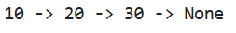
3 | Program to delete a node
SCRIPT | class Node:  def __init__(self, data):  self.data = data  self.next = None  class SinglyLinkedList:  def __init__(self):  self.head = None  def insert(self, data):  new_node = Node(data)  if self.head is None:  self.head = new_node  return  temp = self.head  while temp.next:  temp = temp.next  temp.next = new_node  def delete(self, key):  temp = self.head  if temp and temp.data == key:  self.head = temp.next  return  prev = None  while temp and temp.data != key:  prev = temp  temp = temp.next  if temp is None:  print("Node not found")  return  prev.next = temp.next  def traverse(self):  temp = self.head  while temp:  print(temp.data, end=" -> ")  temp = temp.next  print("None")  sll = SinglyLinkedList()  sll.insert(10)  sll.insert(20)  sll.insert(30)  sll.insert(40)  sll.delete(20)  sll.traverse()
OP
Debugging Questions with Corrected Answers
1 | Debug the following code  Wrong code:  class Node:  def __init__(data):  self.data = data
OP | Error: No error  Correct code:  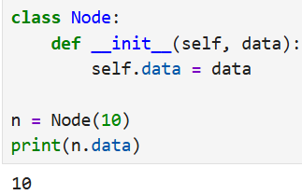
2 | Debug the following code  Wrong code:  if temp.data = key:  head = temp.next
OP | Error: 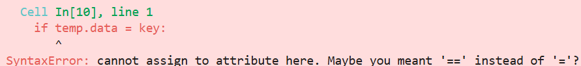  Correct code:  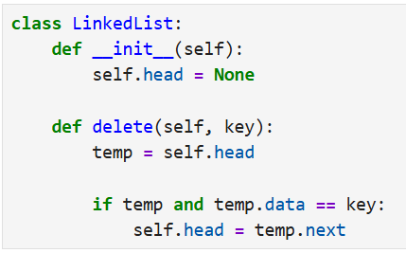
Conclusion

Performance Indicators |  | Teachers Dated and Signature
Process Related  (15 M) | Product Related  (10 M) | Total (25 M)

